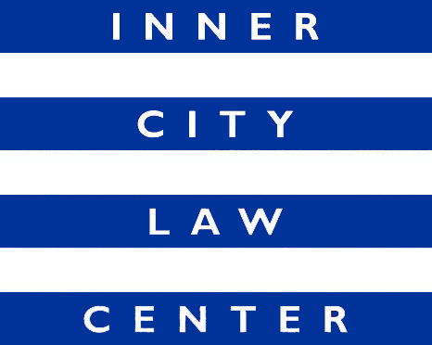
Job Announcement
Supervising Attorney
(Benefits Advocacy Technical Assistance Team)
(Full-Time Position)

Inner City Law Center (ICLC) is a nonprofit law firm on Skid Row. We are looking for extraordinary people to help us end homelessness in Los Angeles. Founded on the fundamental principle that every person should always be treated with dignity and respect, ICLC fights for justice for low-income tenants, working-poor families, people living with disabilities or experiencing homelessness, people living with HIV/AIDS, and homeless veterans.

Position Description: ICLC is seeking a talented, full-time Supervising Attorney to oversee the Benefits Advocacy Technical Assistance Team. The Supervising Attorney will lead a team of five staff members that provide technical assistance to the Los Angeles County Department of Health Services’ CBEST project on disability benefits applications for individuals who are homeless throughout Los Angeles County. In partnership with the Change Well Project, the team also provides similar technical assistance on disability benefits statewide to counties participating in the Housing and Disability Advocacy Program (HDAP). The technical assistance team provides training and guidance, hosts meetings, conducts direct representation of clients in critical vital documents cases, and acts as general legal experts to our partners on disability law and related issues.

The primary responsibility of the Supervising Attorney will be to coordinate the varied work of the Technical Assistance team, which includes representing clients, developing and leading trainings, reviewing applications, hosting meetings, launching projects aimed at improving government benefits law and systems, and providing technical assistance to the Los Angeles County CBEST program and the statewide HDAP program. The Supervising Attorney reports to the Directing Attorney of the Benefits Advocacy Team.

Hiring Criteria: Commitment to ICLC’s mission and values. Excellent oral and written communication skills. Organized and detail oriented. Ability to assume responsibilities quickly and work independently in managing a broad variety of work and projects. Ability to use good judgment, multitask, and move forward multiple projects in collaboration with staff on the team. In-depth knowledge of the substantive and procedural law related to all Social Security programs (SSI, SSDI, Retirement). Experience developing and leading trainings for attorneys and non-attorneys in the area of public benefits law. Membership in the California Bar or another State Bar.

Compensation: Salary commensurate with qualifications and experience. Excellent benefits, including medical, dental and vision insurance, 401k plan, paid lunches, generous paid leave, and more! Come work as a Supervising Attorney at a growing firm with opportunities to advance and learn alongside a team of diverse, talented, and dedicated professionals.

How to Apply: Cover letters and resumes are reviewed upon receipt and applications will be accepted until the position is filled. To apply, please submit your resume and cover letter to https://innercitylaw.org/join-our-team/.

ICLC is an equal opportunity employer and all qualified applicants will receive consideration without regard to their race, religion, ancestry, national origin, sex, sexual orientation, gender identity, transgender status, age, disability, marital status, or medical condition. All qualified applicants with criminal histories shall be considered in a manner consistent with the requirements of the Los Angeles Fair Chance Initiative for Hiring.

To keep our Staff and Clients safe, ICLC requires all Staff to have received the COVID-19 vaccine.

