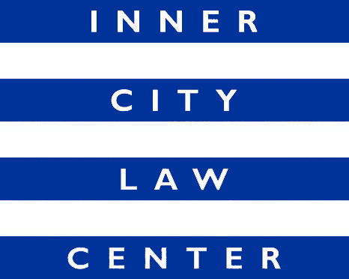

Job Announcement
Supervising Attorney
(Benefits Advocacy Hearings Team)
(Full-Time Position)

Inner City Law Center (ICLC) is a nonprofit law firm on Skid Row. We are looking for extraordinary people to help us end homelessness in Los Angeles. Founded on the fundamental principle that every person should always be treated with dignity and respect, ICLC fights for justice for low-income tenants, working-poor families, people living with disabilities or experiencing homelessness, people living with HIV/AIDS, and homeless veterans.

Position Description: ICLC is seeking a talented, full-time Supervising Attorney to oversee the Benefits Advocacy Hearings Team. The Supervising Attorney will lead a team of four attorneys, three paralegals, and a program coordinator. The team represents very low-income clients who are homeless or at risk of homelessness in their appeals for Social Security Disability Income (SSDI), Supplemental Security Income (SSI), and Cash Assistance Program for Immigrants (CAPI) benefits as part of the Countywide Benefits Entitlement Services Team (CBEST). CBEST is funded through Measure H and is a partnership with the Los Angeles County Department of Health Services.

The primary responsibility of the Supervising Attorney is to coordinate the varied work of the Hearings Team. This position includes training new staff members, mentoring team members, reviewing work product, developing case strategies with staff attorneys, identifying training needs and ways to improve our work, coordinating with our partners at the Department of Health Services, advocating for the team’s needs, and helping to foster a collaborative and healthy work environment. The Supervising Attorney may have a small caseload of clients depending upon availability and need. The Supervising Attorney reports to the Directing Attorney of the Benefits Advocacy Team.

Hiring Criteria: Commitment to ICLC’s mission and values. Excellent oral and written communication skills. Organized and detail oriented. Ability to assume responsibilities quickly and work independently in managing a broad variety of work and projects. Ability to use good judgment, multitask, and move forward multiple projects in collaboration with staff on the team. In-depth knowledge of the substantive and procedural law related to all Social Security programs (SSI, SSDI, Retirement). Commitment to anti-racist and trauma-informed work. Membership in the California Bar or another State Bar. Access to reliable transportation.

Compensation: Salary commensurate with experience. Salary range is $91,000 - $107,000 per year. Excellent benefits.

How to Apply: Cover letters and resumes are reviewed upon receipt and applications will be accepted until the position is filled. To apply, please submit your resume and cover letter to https://innercitylaw.org/join-our-team/.

ICLC is an equal opportunity employer and all qualified applicants will receive consideration without regard to their race, religion, ancestry, national origin, sex, sexual orientation, gender identity, transgender status, age, disability, marital status, or medical condition. All qualified applicants with criminal histories shall be considered in a manner consistent with the requirements of the Los Angeles Fair Chance Initiative for Hiring.

To keep our Staff and Clients safe, ICLC requires all Staff to have received the COVID-19 vaccine.

